Hematuria (Objective I.4)
- Macroscopic hematuria is defined as visible blood in the urine which can present as pink, red, or cola-colored urine. Microscopic hematuria is defined as >5 RBC/mm³ in uncentrifuged urine or >5 RBC/HPF in centrifuged urine on 2 or more occasions (Viteri 2018). The following flow chart adapted from the American Academy of Pediatric provides an algorithm for the evaluation of hematuria in the primary care setting.
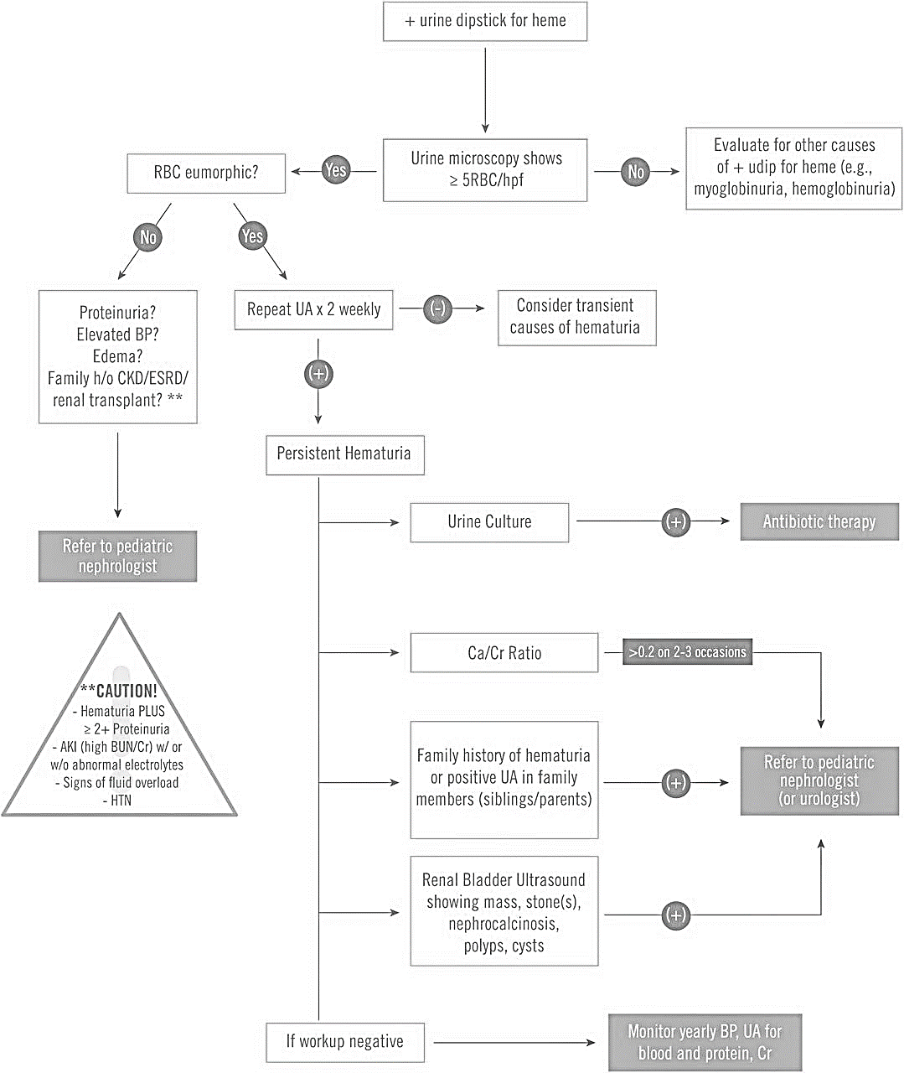
Viteri and Reid-Adam, 2018
- The treatment of hematuria is highly variable depending on the cause. For a review of the causes and appropriate treatment, please see this 2018 Article.

